Youtube Ad Campaign

SARANATHAN COLLEGE OF ENGINEERING



|  |  |
| --- | --- |
| Name | k.Sethuramalingam |
| Naan Mudhalvan ID | EDE571D09BCB7B3B69846ED5F53FCCDD |
| Project Title | Youtube Ad Campaign |

EMAIL ID : [zonecarwash58@gmail.com](mailto:zonecarwash58@gmail.com)

PASSWORD : zonewash58

Team id : NM2023TMID01620

ZONE CAR WASH

NAVIGATION

Demo link - [ZONE CAR WASH](https://youtu.be/GhHQj22Ab6E?si=x5uiZxJU6t1msosI)

STEPS TO CREATE A YOUTUBE AD CAMPAIGN

1.OPEN THE WEBSITE KNOWN AS CANVA .

2.CREATE A FREE ACCOUNT WITH YOUR PERSONAL MAIL ID.

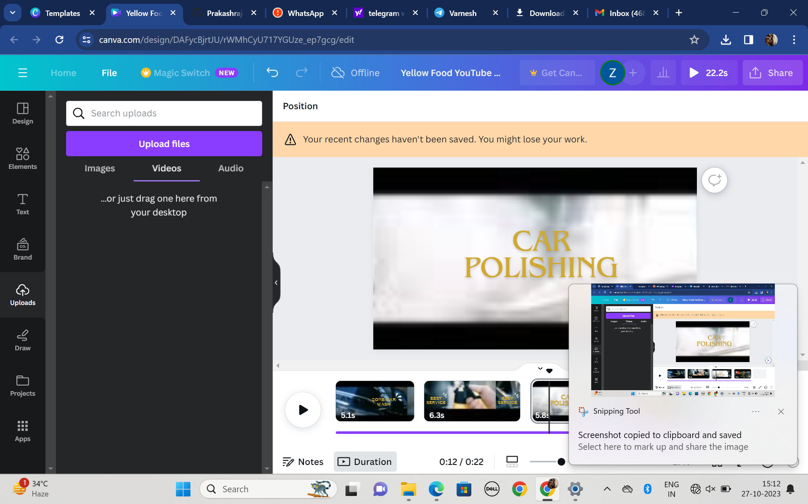

3.PAGE FOR EDITING AND CREATING ADS.

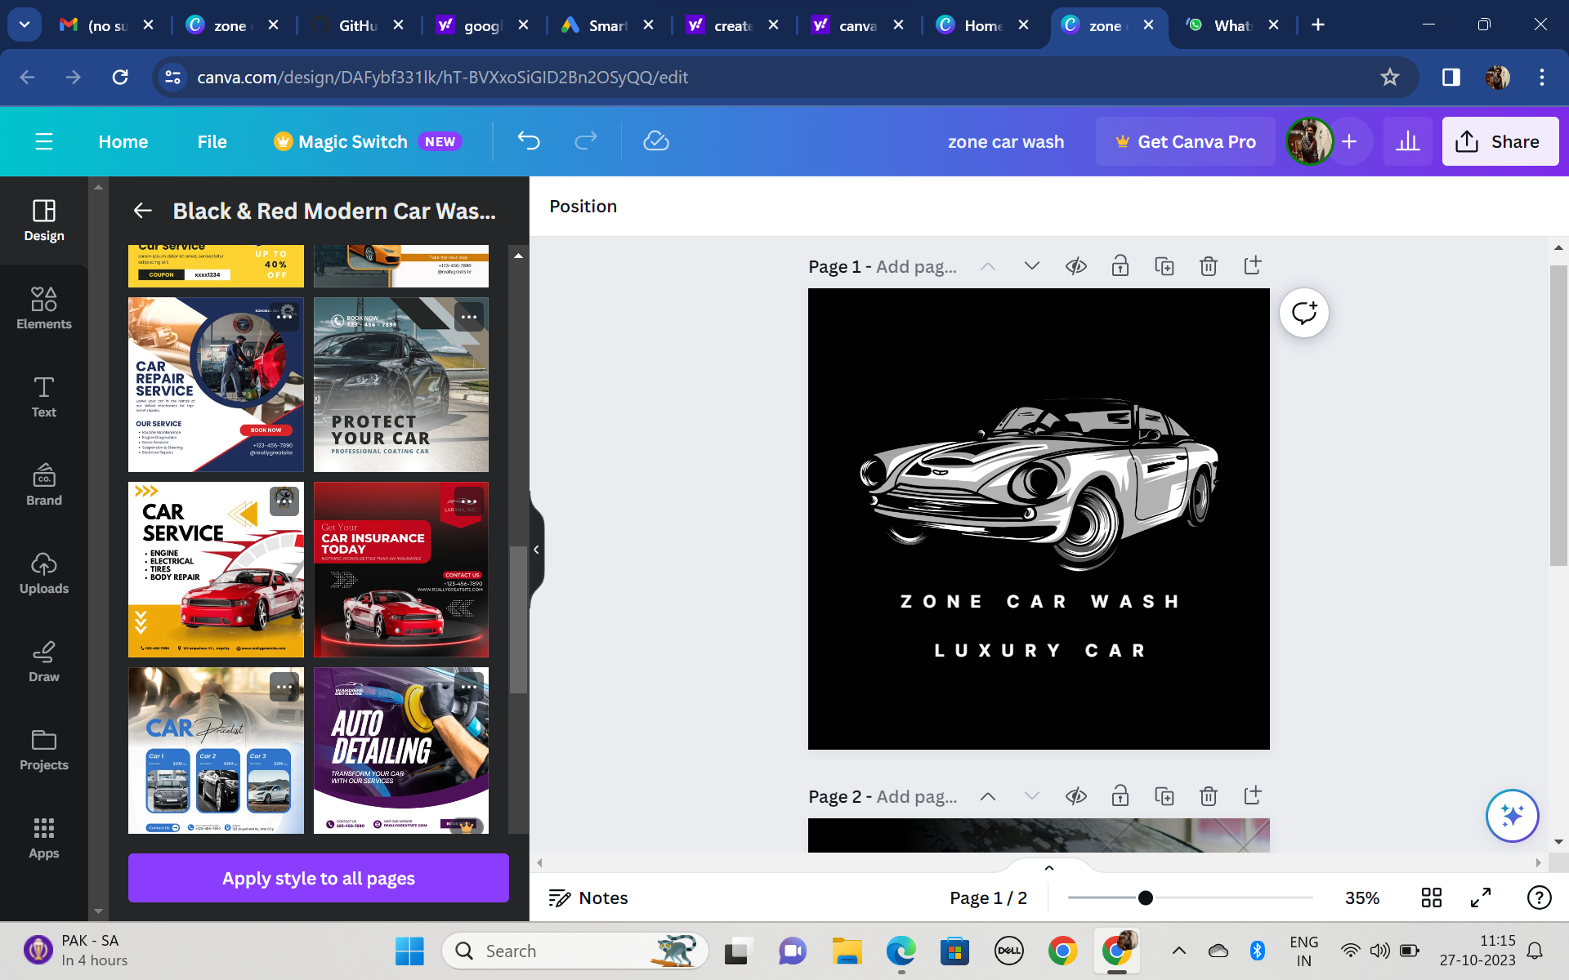

4.PAGE FOR YOUR AD LOGO.

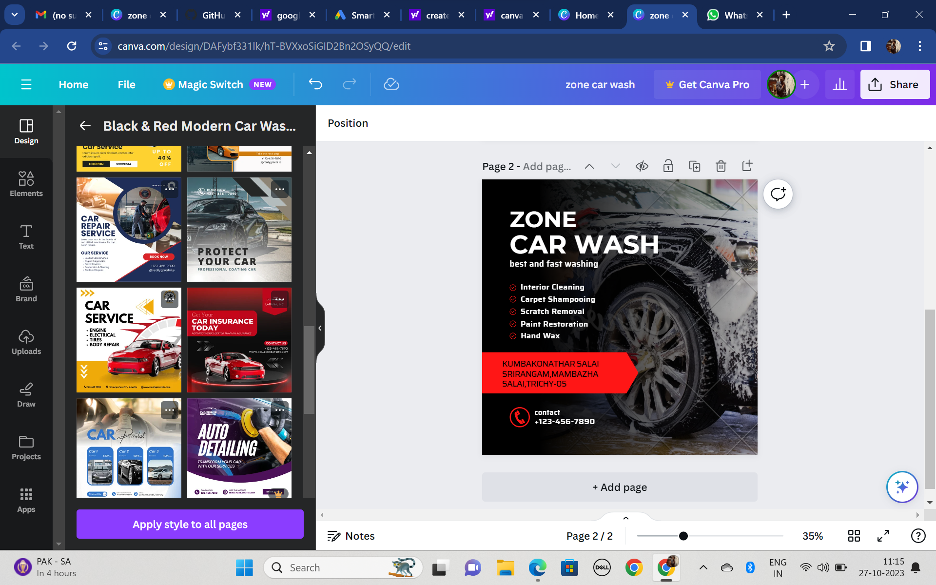

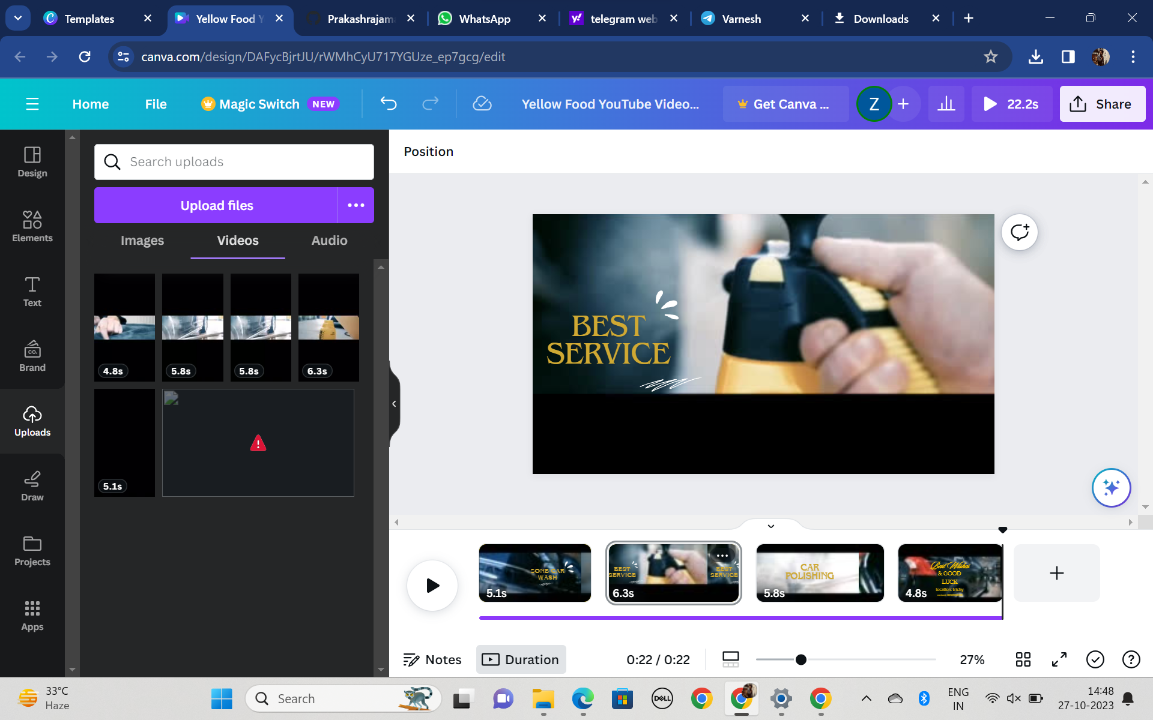

5.EDIT YOUR VIDEO .

